ID :VU4F2223028 Experiment No.:06 Security Lab

**Aim:** Write program to demonstrate integrity management by implementing message digest using MD5.

**Program:**

import hashlib

# Function to generate MD5 hash for a message

def generate_md5_hash(message):

# Encode the message to bytes, and then compute MD5 hash

md5_hash = hashlib.md5(message.encode())

return md5_hash.hexdigest()

# Sample message

message = "Hello, this is a text message."

# Generate and print MD5 hash

md5_result = generate_md5_hash(message)

print(f"Original Message: {message}")

print(f"MD5 Hash: {md5_result}")

**Output:**

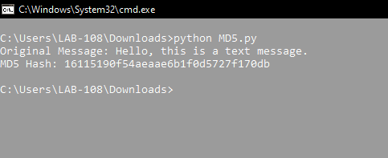

**Conclusion:**

We have suscessfully Demonstrated integrity management by implementing message digest using MD5.